PSG COLLEGE OF TECHNOLOGY-COIMBATORE
DEPARTMENT OF APPLIED MATHEMATICS AND COMPUTATIONAL SCIENCES
III Sem MSc Software Systems - 18XW38 - RDBMS LAB
Problem Sheet – I
Write SQL Statements for the Following Requirements.
- Create a table employee with fields Name (varchar (15)), Designation (varchar (15)), Dept. (varchar (15)), Salary (int), Phone_number (bigint(10)).
CREATE TABLE 19pw38_employee
(Name varchar(15),
Designation varchar(15),
Dept varchar(15),
Salary int,
Phone_number bigint(10)
);

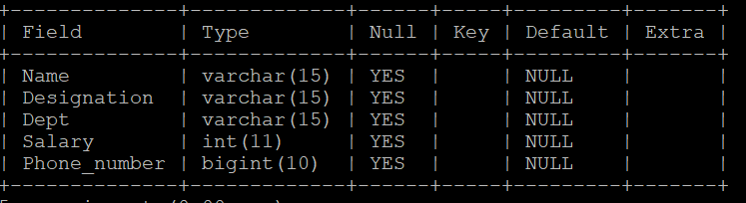

- Add a new column ID (int) as the first column in the employee table.
ALTER TABLE 19pw38_employee
ADD ID int FIRST;

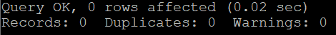

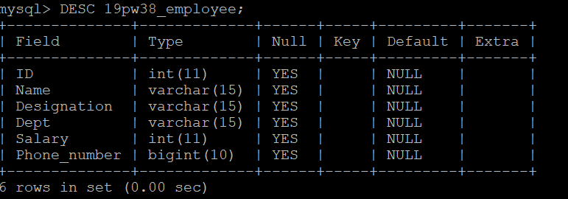

- Add another column City (varchar (15)) after the Salary column and Last_name (varchar (5)) after the Name column.
ALTER TABLE 19pw38_employee
ADD City varchar(15) AFTER Salary,
ADD Last_name varchar(5) AFTER Name;
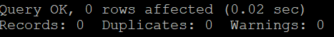

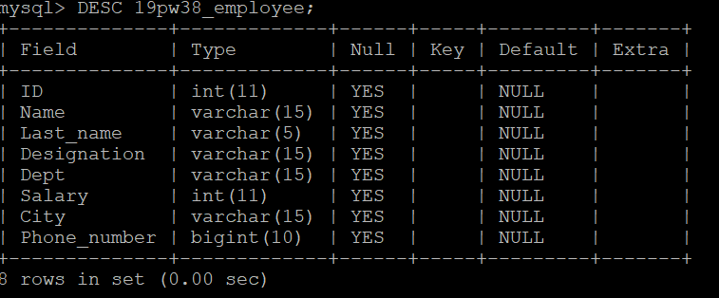

- Change the size of the column Last_name from 5 to 20.
ALTER TABLE 19pw38_employee
MODIFY Last_name varchar(20);
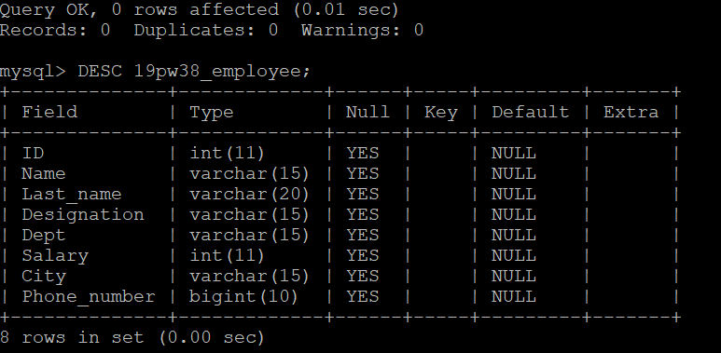

- Add a new column Date_of_joining (date) at the end of the employee table.
ALTER TABLE 19pw38_employee
ADD Date_of_joining date;
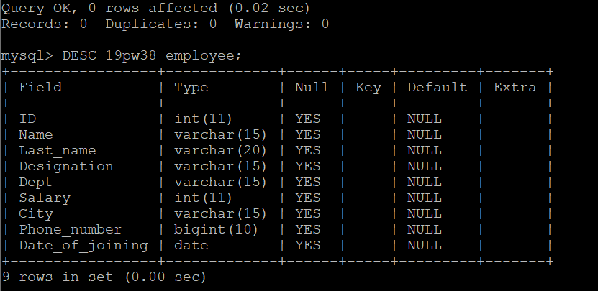

- Change the name of the column ID to EID.
ALTER TABLE 19pw38_employee
CHANGE COLUMN ID EID int;

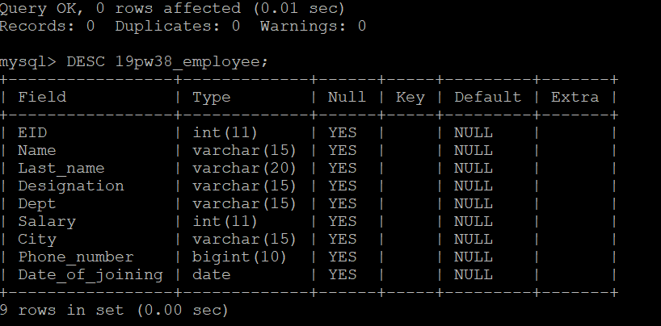

- Add not null constraint to City.
ALTER TABLE 19pw38_employee
MODIFY City varchar(15) NOT NULL;
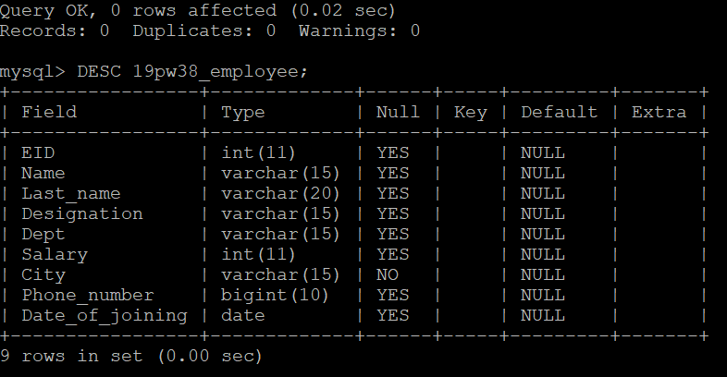

- Remove the Last_name column from the employee table.
ALTER TABLE 19pw38_employee
DROP COLUMN Last_name;
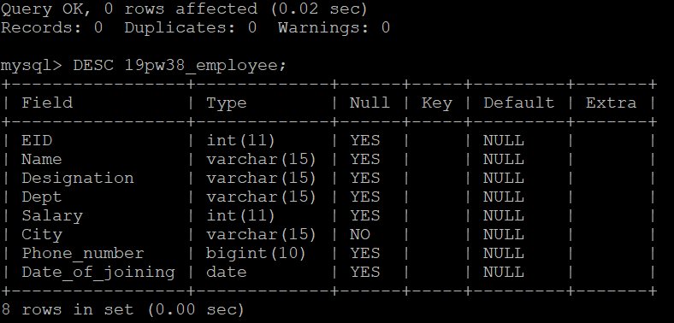

- Create a table dup_employee using employee (use create table as)
CREATE TABLE 19pw38_dup_employee AS
SELECT * FROM 19pw38_employee;
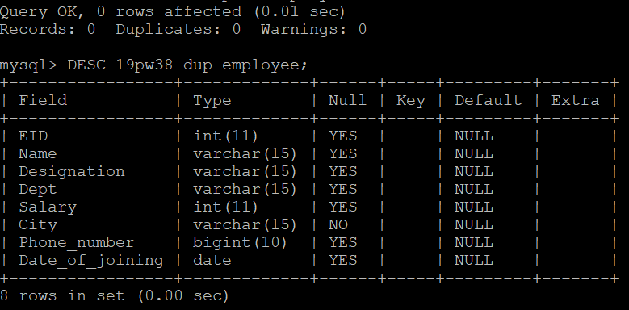

- Change the name of the table employee to employee_data.
RENAME TABLE 19pw38_employee TO 19pw38_employee_data;
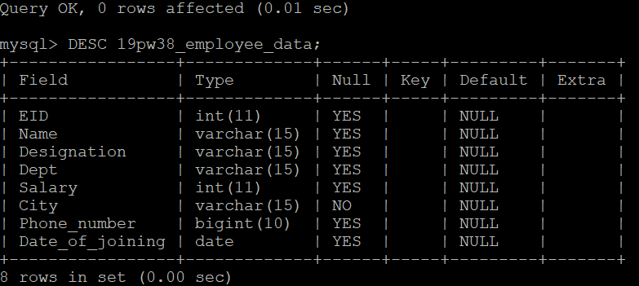

- Delete the dup_employee table.
DROP TABLE 19pw38_dup_employee;

- Display the schema of the employee_data table. (use desc (or) show columns from).
DESC 19pw38_employee_data;
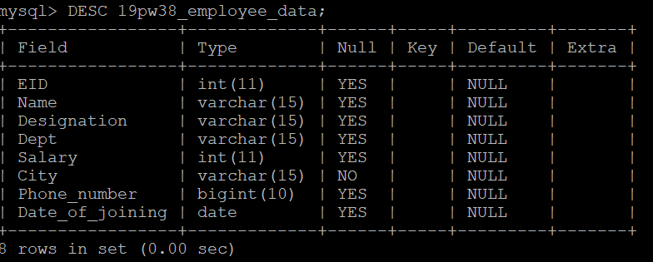

- Insert the first three records given below into the employee_data table.
EID | Name | Designation | Dept | Salary | City | Phone_number | Date_of_ joining
101 | Smith | Manager | Accounts | 20000 | Chennai | 9290249125 | 1980-12-27
407 | Allen | Clerk | Accounts | 5000 | Coimbatore | 9945533992 | 1981-06-09
678 | Scott | Lecturer | ECE | 30000 | Trichy | 9965542211 | 1980-05-01
747 | Jones | Professor | Maths | 35000 | Coimbatore | 9946673321 | 1999-11-12
690 | Adams | Professor | EEE | 50000 | Vellore | 9866544332 | 1979-05-25
579 | Miller | Lecturer | ECE | 25000 | Chennai | 9955778890 | 1999-12-24
671 | Ram | Asst. professor | EEE | 48000 | Chennai | 9877466335 | 1980-10-09
745 | Allex | Senior lecturer | ECE | 46000 | Trichy | 9942266788 | 1999-08-19
742 | Arjun | Professor | EEE | 48000 | Coimbatore | 9977886765 | 1999-12-06
749 | Robert | Lecturer | EEE | 30000 | Coimbatore | 9866778855 | 2005-01-17
845 | Smyth | Clerk | Accounts | 9000 | Salem | 9900007722 | 1973-12-31
INSERT INTO `19pw38_employee_data` (EID, Name, Designation, Dept, Salary, City, Phone_number, Date_of_joining)
VALUES (101, 'Smith', 'Manager', 'Accounts', 20000, 'Chennai', 9290249125, '1980-12-27'),
(407, 'Allen', 'Clerk', 'Accounts', 5000, 'Coimbatore', 9945533992, '1981-06-09'),
(678, 'Scott', 'Lecturer', 'ECE', 30000, 'Trichy', 9965542211, '1980-05-01');
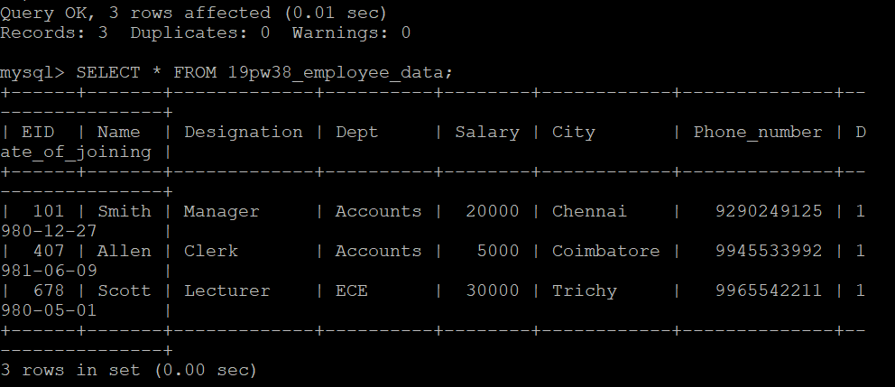

- Remove the three records inserted into the employee_data table using a single SQL statement.
TRUNCATE TABLE 19pw38_employee_data;

- Write a SQL statement to make sure that no duplicate data against column EID will be allowed at the time of insertion.
ALTER TABLE 19pw38_employee_data
ADD PRIMARY KEY (EID);
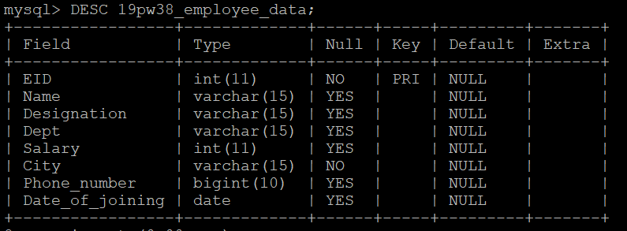

- Insert all the given data into the employee_data table using a single SQL statement.
INSERT INTO 19pw38_employee_data(EID, Name, Designation, Dept, Salary, City, Phone_number, Date_of_joining)
VALUES (101, ‘Smith’, ‘Manager’, ‘Accounts’, 20000, ‘Chennai’, 9290249125, ‘1980-12-27’),
(407, ‘Allen’, ‘Clerk’, ‘Accounts’, 5000, ‘Coimbatore’, 9945533992, ‘1981-06-09’),
(678, ‘Scott’, ‘Lecturer’, ‘ECE’, 30000, ‘Trichy’, 9965542211, ‘1980-05-01’),
(747, ‘Jones’, ‘Professor’, ‘Maths’, 35000, ‘Coimbatore’, 9946673321, ‘1999-11-12’),
(690, ‘Adams’, ‘Professor’, ‘EEE’, 50000, ‘Vellore’, 9866544332, ‘1979-05-25’),
(579, ‘Miller’, ‘Lecturer’, ‘ECE’, 25000, ‘Chennai’, 9955778890, ‘1999-12-24’),
(671, ‘Ram’, ‘Asst. professor’, ‘EEE’, 48000, ‘Chennai’, 9877466335, ‘1980-10-09’),
(745, ‘Allex’, ‘Senior lecturer’, ‘ECE’, 46000, ‘Trichy’, 9942266788, ‘1999-08-19’),
(742, ‘Arjun’, ‘Professor’, ‘EEE’, 48000, ‘Coimbatore’, 9977886765, ‘1999-12-06’),
(749, ‘Robert’, ‘Lecturer’, ‘EEE’, 30000, ‘Coimbatore’, 9866778855, ‘2005-01-17’),
(845, ‘Smyth’, ‘Clerk’, ‘Accounts’, 9000, ‘Salem’, 9900007722, ‘1973-12-31’);
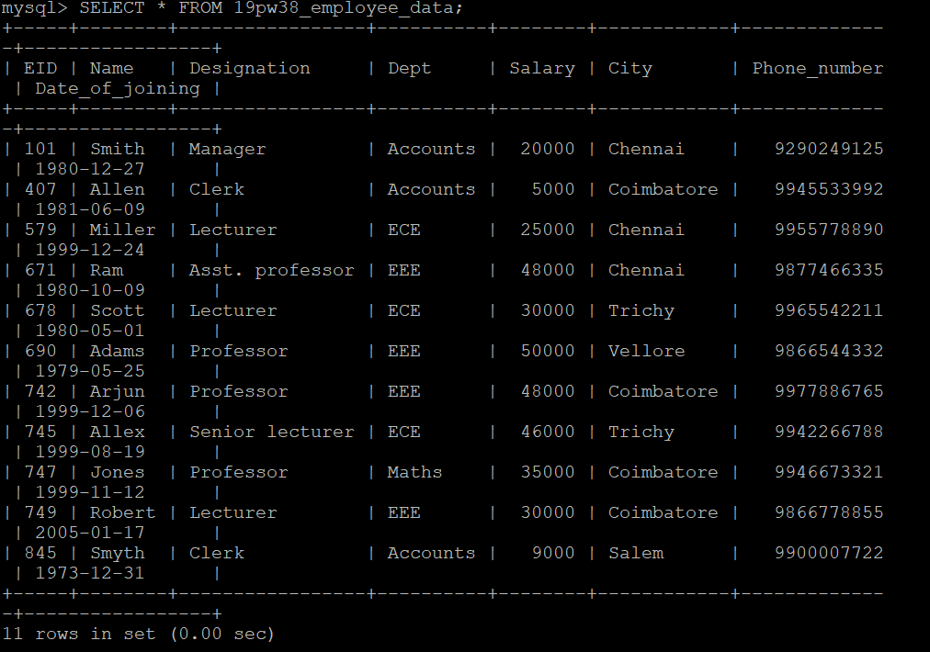

- Create a table CBE_employees (using employee_data table) that includes the details of employees who are from Coimbatore city. (use create table as)
CREATE TABLE `19pw38_CBE_employees` AS SELECT * FROM 19pw38_employee_data WHERE City='Coimbatore';
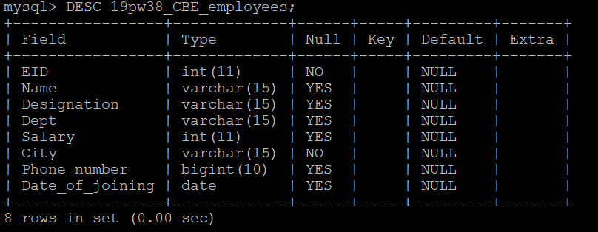
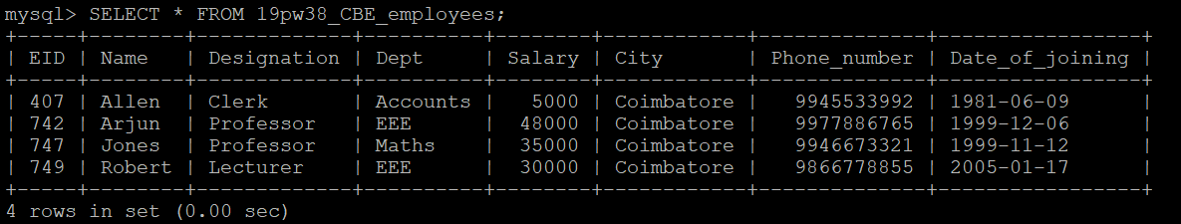

- Create a table Subset_employee and store only the values of EID, Name, Designation, and Phone_number columns of employee_data table using a single SQL statement. (use create table as)
CREATE TABLE 19pw38_Subset_employee AS
SELECT EID, Name, Designation, Phone_number FROM 19pw38_employee_data;
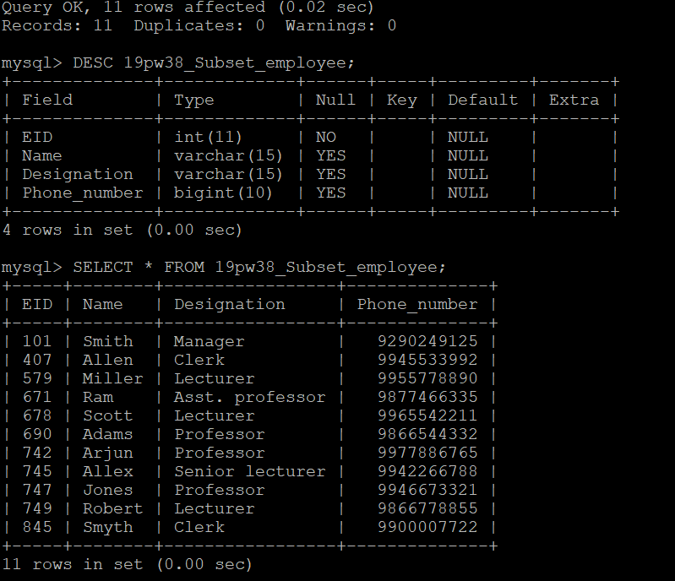

- Add a constraint to the Department column so that the domain values for this column are restricted Accounts, ECE, EEE, and Maths. (use check constraint)
ALTER TABLE 19pw38_employee_data
ADD CHECK (Dept IN (‘Accounts’, ‘ECE’, ‘EEE’, ‘Maths’));

Or

ALTER TABLE `19pw38_employee_data`
ADD CHECK (Dept='Accounts' OR Dept='ECE' OR Dept='EEE' OR Dept='Maths');

- Add a constraint to the Salary column so that it takes any value in the range 5000-50000. (use check constraint)
ALTER TABLE 19pw38_employee_data
ADD CHECK (Salary>=5000 AND Salary<=50000);

- Add a constraint to Phone_number column to store only distinct values. (use check constraint).
ALTER TABLE 19pw38_employee_data
ADD UNIQUE (Phone_number);
Note: All the table names that are given in this problem sheet should be created in MySQL as shown below.
Format : rollno_tablename
For Example : 19pw01_employee

